How Far Can You Chunk a (candied) Pumpkin?
Objective: To design, construct, build, and test a catapult device that will fling a candied pumpkin as far as possible.
Materials: Toothpicks, Popsicle sticks, rubber bands, pipe cleaners, straws, yarn, spoons, legos, tape and glue
Task: Use what you learned about catapults and follow the problem-solving process to produce your own tiny version of a catapult that will throw candied pumpkins. You will need to document each step of the process, as well as to take pictures of your team designing, building, and testing your device. Ultimately, your team will develop a PowerPoint to show off your project!
Roles for Team Members:
- Team Leader: Keeps project on task and solicits ideas from all members
- Recorder: Jots and keeps notes on each step of the problem-solving process
- Photographer: Takes Pictures of team performing steps along the way (save pictures to H: drive)
- Designers, Builders, Testers: All Team Members should participate in these tasks
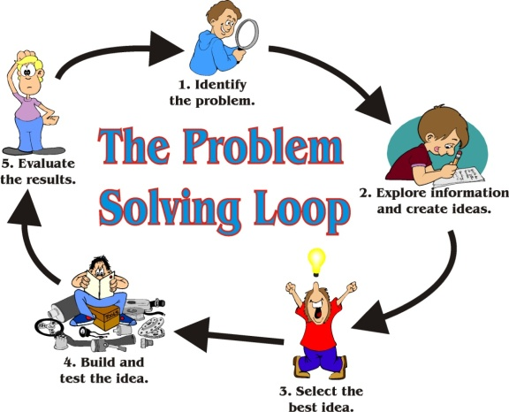
Rubric:
10 Points: Completed working catapult
12 Points: Completed PowerPoint (six slides, title plus one for each problem-solving step, pictures on each slide)
3 Points: Completed team evaluation
25 Points Total

