Name________________________

LEGO Robot Reflection and Brainstorm
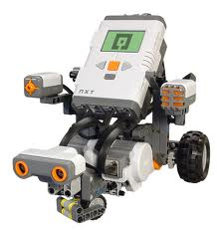
Using Microsoft Word, please complete the assignments below. Each should be a separate Word document. You will be graded on spelling, punctuation, transitional words, etc. It is expected that you complete your best 7th grade work.
- Write a 1 page typed paper that describes how you could use a LEGO robots in “real” life. Include its functions, purpose and what “job” it would replace in real life.

- Write a ½ typed page reflection on your experience learning and using LEGO robots. What did you enjoy? What did you learn? What did you dislike, be descriptive.

- Next, have a friend take a digital picture of you with the LEGO robot. Save this picture to your thumb drive and/or H drive. When picture is saved delete from camera. We will upload pictures and captions to your Weebly webpage Thursday.

- Finally, write a caption for your picture that describes your experience with LEGO robots.

*Writing assignments are due at the beginning of class Thursday; please drop both assignments to me.

Title the assignments: first initial, last name real life
first initial, last name reflection

